**Setting Up Chef-Workstation**

##### **Step 1: Update your OS**

# apt-get update

**Step 2:Install NTP and git**

# apt-get install ntp git -y

##### **Step 3 : Download latest Chef Development Kit**

wget   https://packages.chef.io/files/stable/chefdk/1.2.22/ubuntu/14.04/chefdk_1.2.22-1_amd64.deb

##### **Step 4 : Install ChefDK**

# dpkg -i chefdk_1.2.22-1_amd64.deb

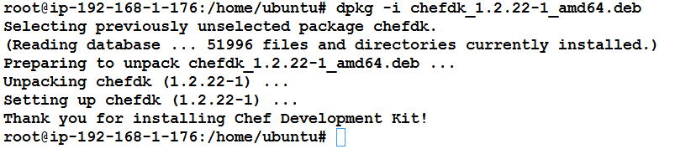

For RHEL :

wget https://packages.chef.io/files/stable/chefdk/1.0.3/el/7/chefdk-1.0.3-1.el7.x86_64.rpm

rpm -ivh chefdk-0.11.2-1.el7.x86_64.rpm

##### **Step 6: Verify the components of the development kit in opt/chefdk**

Note : the Chef development kit to your machine. The Chef development kit is installed to /opt/chefdk/ on UNIX and Linux systems.

ls -l /opt/chefdk/bin/

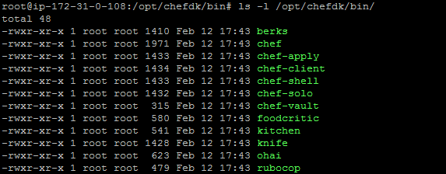

##### **Step 7: Verify the components of the development kit**

# chef verify

This will verify the main components of the Chef development kit: the chef-client, the Chef development kit library, and the tools that are built into the Chef development kit. The output should be similar to:

